https://www.sourcecodester.com/php/9668/upload-and-download-files-php.html
Skip to main content


Main navigation
- Home
- Blog
- Projects
- Programming
- Compilers
- Mobile
- Tutorials
- Contact
- Submit Code
- Log In
Top of Form


Bottom of Form
Top of Form
Bottom of Form
- PHP
- Upload and Download Files in PHP/PDO Tutorial

Upload and Download Files in PHP/PDO Tutorial
Submitted by Jeprox on Monday, December 28, 2020 - 11:36.
Language
PHP
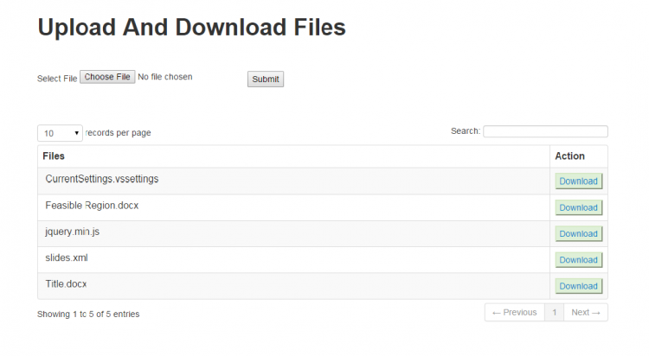
In this simple source code, you can learn how to manage (upload/download) files using PHP/PDO. The simple project can store different types/formats of files and also the user can download the uploaded file. The source code can detect if the file name has duplicates and will automatically add a number for example if the filename "sample.pdf" already exists in the database the system will store the file as "sample_2.pdf" and if ever user will upload a file using the same filename the system will also check if the new filename has no duplicates. In addition to the example scenario, if the user will upload "sample.php", the system will change it into "sample_3".

Acceptable File Format extensions
- pdf
- txt
- html
- htm
- exe
- zip
- doc
- xls
- ppt
- gif
- png
- jpeg
- jpg
- php

Creatin a Simple Upload/Download System

Set up a local webserver
- First, download and Install the XAMPP to run a PHP script on your local machine.
- After the successful installation, run the XAMPP Control Panel and start the "Apache" and "MYSQL".
- Then, open a web browser and browse "localhost/phpmyadmin"
- Create a New Database and name it as "demo". Then click the SQL navigation and Copy/Paste the code below

  - CREATE TABLE `upload` (
  - `id` int(11) NOT NULL,
  - `fname` text NOT NULL,
  - `name` varchar(200) NOT NULL
  - ) ENGINE=InnoDB DEFAULT CHARSET=latin1;

  - ALTER TABLE `upload` ADD PRIMARY KEY (`id`);

  - ALTER TABLE `upload` MODIFY `id` int(11) NOT NULL AUTO_INCREMENT; COMMIT;

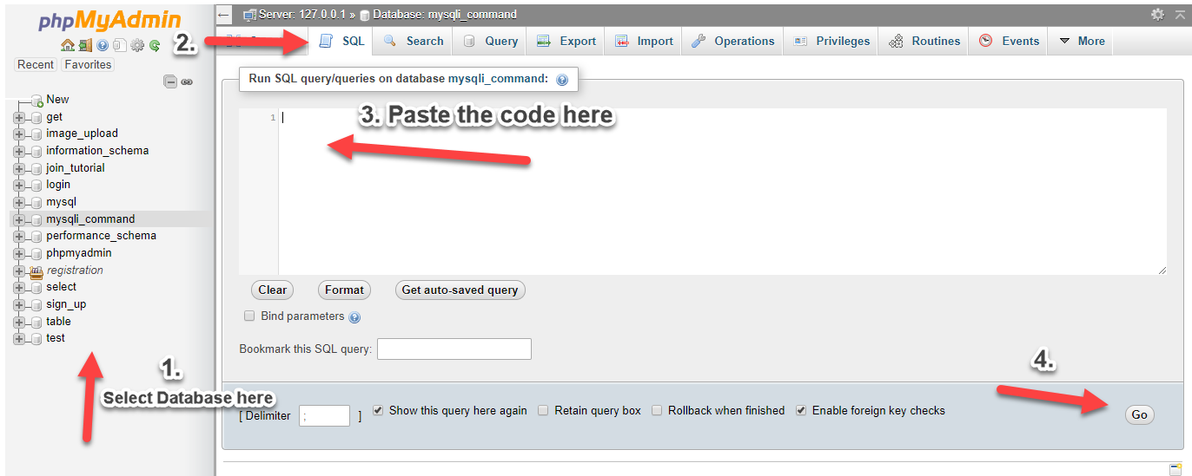

File Upload Form
- <form enctype="multipart/form-data" action="" name="form" method="post">
- Select File
- <input type="file" name="file" id="file" /></td>
- <input type="submit" name="submit" id="submit" value="Submit" />
- </form>

File Upload PHP Script
- <?php
- $conn=new PDO('mysql:host=localhost; dbname=demo', 'root', '') or die(mysql_error());
- if(isset($_POST['submit'])!=""){
- $name=$_FILES['file']['name'];
- $size=$_FILES['file']['size'];
- $type=$_FILES['file']['type'];
- $temp=$_FILES['file']['tmp_name'];
- $fname = date("YmdHis").'_'.$name;
- $chk = $conn->query("SELECT * FROM upload where name = '$name' ")->rowCount();
- if($chk){
- $i = 1;
- $c = 0;
- while($c == 0){
- $i++;
- $reversedParts = explode('.', strrev($name), 2);
- $tname = (strrev($reversedParts[1]))."_".($i).'.'.(strrev($reversedParts[0]));
- $chk2 = $conn->query("SELECT * FROM upload where name = '$tname' ")->rowCount();
- if($chk2 == 0){
- $c = 1;
- $name = $tname;
- }
- }
- }
- $move = move_uploaded_file($temp,"upload/".$fname);
- if($move){
- $query=$conn->query("insert into upload(name,fname)values('$name','$fname')");
- if($query){
- header("location:index.php");
- }
- else{
- die(mysql_error());
- }
- }
- }
- ?>

Uploaded file Table List
- <table cellpadding="0" cellspacing="0" border="0" class="table table-striped table-bordered" id="example">
- <thead>
- <tr>
- <th width="90%" align="center">Files</th>
- <th align="center">Action</th>
- </tr>
- </thead>
- <?php
- $query=$conn->query("select * from upload order by id desc");
- while($row=$query->fetch()){
- $name=$row['name'];
- ?>
- <tr>
- <td>
- &nbsp;<?php echo $name ;?>
- </td>
- <td>
- <button class="alert-success"><a href="download.php?filename=<?php echo $name;?>&f=<?php echo $row['fname'] ?>">Download</a></button>
- </td>
- </tr>
- <?php }?>
- </table>

Download File Script
- <?php
- function output_file($file, $name, $mime_type='')
- {
- if(!is_readable($file)) die('File not found!');

- $size = filesize($file);
- $name = rawurldecode($name);
- $known_mime_types=array(
- "pdf" => "application/pdf",
- "txt" => "text/plain",
- "html" => "text/html",
- "htm" => "text/html",
- "exe" => "application/octet-stream",
- "zip" => "application/zip",
- "doc" => "application/msword",
- "xls" => "application/vnd.ms-excel",
- "ppt" => "application/vnd.ms-powerpoint",
- "gif" => "image/gif",
- "png" => "image/png",
- "jpeg"=> "image/jpg",
- "jpg" => "image/jpg",
- "php" => "text/plain"
- );
- if($mime_type==''){
- $file_extension = strtolower(substr(strrchr($file,"."),1));
- if(array_key_exists($file_extension, $known_mime_types)){
- $mime_type=$known_mime_types[$file_extension];
- } else {
- $mime_type="application/force-download";
- };
- };

- @ob_end_clean();

- if(ini_get('zlib.output_compression'))
- ini_set('zlib.output_compression', 'Off');
- header('Content-Type: ' . $mime_type);
- header('Content-Disposition: attachment; filename="'.$name.'"');
- header("Content-Transfer-Encoding: binary");
- header('Accept-Ranges: bytes');
- header("Cache-control: private");
- header('Pragma: private');
- header("Expires: Mon, 26 Jul 1997 05:00:00 GMT");
- if(isset($_SERVER['HTTP_RANGE']))
- {
- list($a, $range) = explode("=",$_SERVER['HTTP_RANGE'],2);
- list($range) = explode(",",$range,2);
- list($range, $range_end) = explode("-", $range);
- $range=intval($range);
- if(!$range_end) {
- $range_end=$size-1;
- } else {
- $range_end=intval($range_end);
- }
- $new_length = $range_end-$range+1;
- header("HTTP/1.1 206 Partial Content");
- header("Content-Length: $new_length");
- header("Content-Range: bytes $range-$range_end/$size");
- } else {
- $new_length=$size;
- header("Content-Length: ".$size);
- }
- $chunksize = 1*(1024*1024);
- $bytes_send = 0;
- if ($file = fopen($file, 'r'))
- {
- if(isset($_SERVER['HTTP_RANGE']))
- fseek($file, $range);

- while(!feof($file) &&
- (!connection_aborted()) &&
- ($bytes_send<$new_length)
- )
- {
- $buffer = fread($file, $chunksize);
- print($buffer);
- flush();
- $bytes_send += strlen($buffer);
- }
- fclose($file);
- } else

- die('Error - cannot open file.');
- die();
- }
- set_time_limit(0);
- $file_path='upload/'.$_REQUEST['f'];
- output_file($file_path, ''.$_REQUEST['filename'].'', 'text/plain');
- ?>
That source code above are important script you will need in developing a simple Upload and Download File System. You can also use bootstrap for the design of your project. Feel Free to Copy and paste the source codes above and try develop a simple file upload and download system on your own. Also, you can download the working project source code below.

DEMO
Happy Coding :)

For more PHP tutorials, visit the link below.
PHP Tutorials

For a Free PHP project w/ Source Code, visit the link below.
Free PHP Project with Source Code
Top of Form
Bottom of Form
Note: Due to the size or complexity of this submission, the author has submitted it as a .zip file to shorten your download time. After downloading it, you will need a program like Winzip to decompress it.
Virus note: All files are scanned once-a-day by SourceCodester.com for viruses, but new viruses come out every day, so no prevention program can catch 100% of them.
FOR YOUR OWN SAFETY, PLEASE:
1. Re-scan downloaded files using your personal virus checker before using it.
2. NEVER, EVER run compiled files (.exe's, .ocx's, .dll's etc.)--only run source code.
Tags
upload
download files
php
PDO
file management

Comments
Submitted by akino009 on Fri, 09/25/2015 - 11:49

cant download the files i uploaded
when i hit download button it says file not found
- Log in or register to post comments
Submitted by kadzz on Sun, 04/23/2017 - 01:40
In reply to cant download the files i uploaded by akino009

cant download files
is there anyone can explain why cant download the file i uploaded? TIA
- Log in or register to post comments
Submitted by Prakher Srivastava (not verified) on Fri, 02/16/2018 - 19:30
In reply to cant download the files i uploaded by akino009

Solved File not Found Error.
On Index.php on line 10 change
move_uploaded_file($temp,"files/".$name);
to
move_uploaded_file($temp,"upload/".$name);
- Log in or register to post comments
Submitted by kadzz on Sun, 04/23/2017 - 02:23

file not found
cant download any files sir please help TIA
- Log in or register to post comments
Submitted by Varma (not verified) on Tue, 06/20/2017 - 22:17

Download link is not working
Download link is not working
- Log in or register to post comments
Submitted by Derf (not verified) on Thu, 05/22/2025 - 00:32
In reply to Download link is not working by Varma (not verified)

Download issue
I know this is old but change: if(!is_readable($file)) die('File not found!'); to if(is_readable($file)) die('File not found!'); Remove the ! and download works. Not readable but working on trying to figure out why.
- Log in or register to post comments
Submitted by anony (not verified) on Fri, 07/21/2017 - 17:06

download
download function, there is no file downloaded. System prompt file not exist.
- Log in or register to post comments
Submitted by nikosttttttt (not verified) on Thu, 02/15/2018 - 23:44

n
thank you very much
- Log in or register to post comments
Submitted by kartik124 (not verified) on Sat, 03/24/2018 - 21:43
In reply to n by nikosttttttt (not verified)

download
what changes you made in the download file
- Log in or register to post comments
Submitted by PriyaSinha (not verified) on Wed, 04/04/2018 - 02:51

Awesome work
Thanks alot. It's woking fine.
- Log in or register to post comments
Submitted by rookie (not verified) on Wed, 05/09/2018 - 03:05

Amazing code
Thank you so much for the code. You are the best!
- Log in or register to post comments
Submitted by glen09090990 (not verified) on Wed, 05/23/2018 - 10:33

download
Hi, download button is not working, Please check. Thank you
- Log in or register to post comments
Submitted by manojkanur (not verified) on Fri, 03/15/2019 - 15:47
In reply to download by glen09090990 (not verified)

upload and download reference
want to compare how its work
- Log in or register to post comments
Submitted by Manish Pareek (not verified) on Thu, 06/20/2019 - 20:15

Upload Error
Just Change Line No 9 to move_uploaded_file($temp,"upload/".$name);
- Log in or register to post comments
Submitted by serverootdb (not verified) on Thu, 05/21/2020 - 20:56

working good even the folder
thanks sir
- Log in or register to post comments
Submitted by Mirek (not verified) on Wed, 02/17/2021 - 16:37

Thanks for tutorial ! Tell…
Thanks for tutorial ! Tell me.. how do : I want copy download link and share it - how display only http link ?
- Log in or register to post comments
Submitted by parth kakadiya (not verified) on Sat, 04/03/2021 - 19:55

url not fount
The requested URL was not found on this server.
- Log in or register to post comments
Submitted by Sercan Deniz (not verified) on Mon, 07/05/2021 - 16:08

My files are corrupted, I…
My files are corrupted, I changed my code like they said in the comments but it doesn't work for me.
- Log in or register to post comments
Submitted by Sahnawaj Khan (not verified) on Mon, 12/26/2022 - 13:39

Thank You So much Dear SIr…
Thank You So much Dear SIr/mam I am very Happy To Download this SOurce Code
- Log in or register to post comments
- Log in or register to post comments
- 31222 views

Share Source Code or Tutorial
Do you have source code, articles, tutorials or thesis to share? Submit it here by clicking the link below

Submit now...

Popular Source Code
Free and Open Source inventory management system php source code
Billing Application Using HTML, CSS and JavaScript with Source Code
Inventory Management System in PHP with Source Code
Student Management System Project in PHP
Online Learning Management System using PHP/MySQLi with Source Code
Attendance Management System using PHP with Source Code
Online Health Care System in PHP with Full Source Code
Web-based Pharmacy Product Management System using PHP and MySQL Database
Online Food Ordering System v2 using PHP8 and MySQL Free Source Code
Student Management System in PHP/MySQL Source Code

User account menu
- Log in

Book navigation
- SQL Tutorial
- PHP Tutorial
- CodeIgniter Tutorial
- Android Tutorial
- Visual Basic Tutorial
- C# Tutorial
- CSS Tutorial
- Learn C in 15 Days
- Object Oriented Programming in C++
- Data Structures in C++
- Fundamentals of C Language
- Learn Object Oriented Programming in C++
- Java Tutorial
- Python Tutorial

Recent content
- Checker Game Using HTML & CSS in VanillaJS with Source Code
9 minutes ago
- How to Count Digits and Letters in a String in Python
25 minutes ago
- Color Picker App Using HTML & CSS in JavaScript with Source Code
2 days ago
- Catching and Responding to Keyboard Events in JavaScript with Source Code
2 days ago
- Andy's Oracle utilities
5 days 14 hours ago
- Foosball Game Using HTML & CSS in VanillaJS with Source Code
1 week ago
- How to Reverse a String Using Recursion in Python
1 week ago
- Bug Smasher Game Using HTML & CSS in JavaScript with Source Code
1 week 2 days ago
- How to Find All Perfect Squares in a Given Range in Python
1 week 2 days ago
- Cryptocurrency Converter Using HTML, CSS and JavaScript with Source Code
1 week 2 days ago
Advertise Here | FAQ | Forums | About Us | Hire Us

Privacy Statement | Disclaimer | Terms and Agreement
Computer

